CHEYENNE LIGHT, FUEL AND POWER COMPANY
BLOCKCHAIN INTERRUPTIBLE SERVICE
REQUEST FOR PROPOSALS

Issue date: August 24, 2021
Response deadline: September 7, 2021

Table of Contents
Introduction 1
Bid Submittal 2
Bid Form - Section 1 - Bid Checklist 3
Bid Form - Section 2 - Company/Contact information 4
Bid Form - Section 3 - Project Specifics 5
Bid Form - Section 4 - Pricing Proposal 6
Appendix 8
Appendix - Blockchain Interruptible Service (BCIS) Tariff 9
Appendix - Cheyenne Light Substation Availability 13
Appendix - Non-Disclosure Agreement 14

Introduction
Black Hills Corp. (NYSE: BKH) is a customer-focused, growth-oriented utility company with a tradition of improving life with energy and a vision to be the energy partner of choice. Based in Rapid City, South Dakota, the company serves 1.3 million natural gas and electric utility customers in eight states: Arkansas, Colorado, Iowa, Kansas, Montana, Nebraska, South Dakota and Wyoming. More information is available at www.blackhillscorp.com, www.blackhillscorp.com/corporateresponsibility and www.blackhillsenergy.com.
Black Hills Corporation through its wholly owned subsidiary Cheyenne Light, Fuel and Power Company is soliciting proposals from potential Blockchain Interruptible Service (“BCIS”) customers. Cheyenne Light, Fuel and Power Company dba Black Hills Energy (“Cheyenne Light”) serves over 43,000 electric customers in Cheyenne, Wyoming and the surrounding vicinity.
This document is the RFP and serves as written application to Cheyenne Light for service under its BCIS Tariff. This RFP is for respondents to propose pricing and terms related to taking service under a to be negotiated BCIS agreement. Cheyenne Light desires to enter into one or more BCIS agreement(s) as a result of this RFP. However, Cheyenne Light may require additional information, and Cheyenne Light and the applying customer may, at the sole discretion of either party, cease negotiation of rates and terms and conditions of service under the BCIS Tariff. If the parties agree through negotiations to electric service through the BCIS Tariff, an Agreement will be executed. The electric service under the BCIS Tariff is not applicable to temporary, standby, supplementary, emergency, resale, shared or incidental purposes.
The agreement for service under the BCIS tariff must include:
- Electric service is for new interruptible load expected to be 10,000 kW or greater;
- A term of at least two (2) years;
- Specific pricing for all electricity purchased, with the pricing terms being subject to renegotiation at least every three (3) years;
- Negotiated service interruption provisions (size of interruptible load, notice of planned interruption, duration of interruption, and maximum hours of interruption per year);
- Other requirements as defined in the BCIS tariff (see appendix).

Cheyenne Light will give preference to bids with the highest price, accept high curtailment/interruptible hours and are in desirable locations. The Company will also factor in the bidder’s credit quality and the ability for the bidder to transact quickly.
All system upgrade or system interconnection costs will be borne by the respondent. Cheyenne Light will endeavor to provide an estimate to the short-listed bidders of the expected costs to interconnect to its facilities during the screening process and the notice to the short-listed bidders.
All proposals received will be handled confidentially.

Bid Submittal
Proposal Submissions
Proposals must be submitted in the complete name of the party expecting to execute any resulting BCIS Agreement with Cheyenne Light. The proposal must be executed by a person who is duly authorized to bind the respondent to a contract.
Bidders can submit alternate proposals for price, location, or curtailable hours. However, please submit a complete package for each alternative location proposed. If alternate pricing and/or curtailable hours are proposed from the same location, please submit a new Section 3-Pricing for each proposal.
All proposals submitted in response to this RFP must be received by Cheyenne Light no later than 5:00 pm MDT on the due date at BCIS_RFP@blackhillscorp.com. To ensure receipt, please send e-mails from a United States service provider.
Schedule
Issue RFP | August 24, 2021
RFP Responses due | September 7, 2021
Screening of bids complete | September 30, 2021
Notice to short-listed bidders | September 30, 2021
Execution of BCIS Agreement | October 15, 2021

Questions
Cheyenne Light will accept questions via email to BCIS_RFP@blackhillscorp.com. Cheyenne Light requests that all questions concerning this RFP be submitted in writing at the above address. Answers will be provided through email correspondence to and from this address only. Written questions will be accepted by Cheyenne Light through September 3rd.

Required attachments:
All bids must include the entity’s certificate of good standing and most recent financial statements. If no financial statements exist, the bidder must detail its financial condition or show other means to fund the project. Additionally, please provide details regarding credit support and preference for form of credit support (e.g. letter of credit). Bids without any financial detail regarding the bidder’s ability to fund the project or support credit requirements will not be considered.
With each proposal Cheyenne Light will require all parties to sign the Non-disclosure Agreement, contained in Appendix - Non-disclosure Agreement to this RFP. Cheyenne Light will sign and execute the Non-disclosure Agreement upon receipt from each Respondent. Cheyenne Light will use commercially reasonable efforts, in a manner consistent with the Non-disclosure Agreement, to protect any claimed proprietary and confidential information contained in a proposal.

- See Bid Form - Section 1 - Bid Checklist

Bid Form - Section 1 - Bid Checklist

Signed Bid Form - Section 2 - Contact/Company information
Bid Form - Section 3 - Project Specifics
Bid Form - Section 4 - Pricing Proposal
Attached certificate of good standing
Attached financial statements
Completed and Signed Non-Disclosure Agreement

Bid Form - Section 2 - Company/Contact information
Contact name:

Full legal name of bidding entity:

State of incorporation:

Address:

Phone:

Email:

Signature:

Bid Form - Section 3 - Project Specifics
Describe the project:

Desired interconnection substation: (please see appendix for list)

Project’s physical address:

Project’s latitude and longitude:

Project’s facility description: (containers or building, etc.)

Project’s desired start date:

Project’s expected megawatts of demand at start, schedule of increase over time, and final demand at project completion:

Project’s site preparation: (permitting requirements complete (if applicable), has land been acquired, is a lease option preferred?)

Does the bidding entity currently have cryptocurrency mining operations? If yes, how many megawatts?

Bid Form - Section 4 - Pricing Proposal
Cheyenne Light will entertain proposals for fixed price supply. In the tables below please provide the proposed total or all-in pricing the bidder is willing to pay under a BCIS Agreement. Priority will be placed on price as well as on the number of curtailment hours.
As required in the tariff, the BCIS Agreement requires a bid reopener after three years. However, the bidder may propose pricing and terms beyond that time.
Please complete the table below with the proposed bid (add rows or columns as necessary). It should be completed in cents per kilowatt hour.
Term | Total Bid
Example (Jan-Dec 2022) | $.0XX/kwh
Example (Jan-Dec 2023)

Please list the maximum hours the project would be willing to be curtailed annually due to uneconomic market energy prices. Cheyenne Light retains the right to curtail load for system safety and integrity beyond the hours indicated below as necessary.
XXX hours

Is the bidder willing to pay a premium during hours in which power supply cost exceeds the bid price to avoid being curtailed? (Yes/No)

Is the bidder interested in off-peak only energy or tiered pricing during on-peak vs off-peak hours? If so please explain further.

Please indicate any other information related to bid pricing you wish to share with Cheyenne Light for your bid:

Project funding and credit support:
Cheyenne Light will assess the bidders’ ability to fund the project and bidders’ credit quality. At a minimum, the bidder can expect to post credit support equal to multiple months of the project’s electric utility bill. Bidders with less credit history or without excellent credit can expect to provide more credit support.
Please detail proposed project funding: (Is funding secured or in process?)

Please detail your proposed credit support for this bid:

Appendix

Appendix - Cheyenne Light BCIS Tariff
Appendix - Cheyenne Light Substation Availability
Appendix - Non-Disclosure Agreement

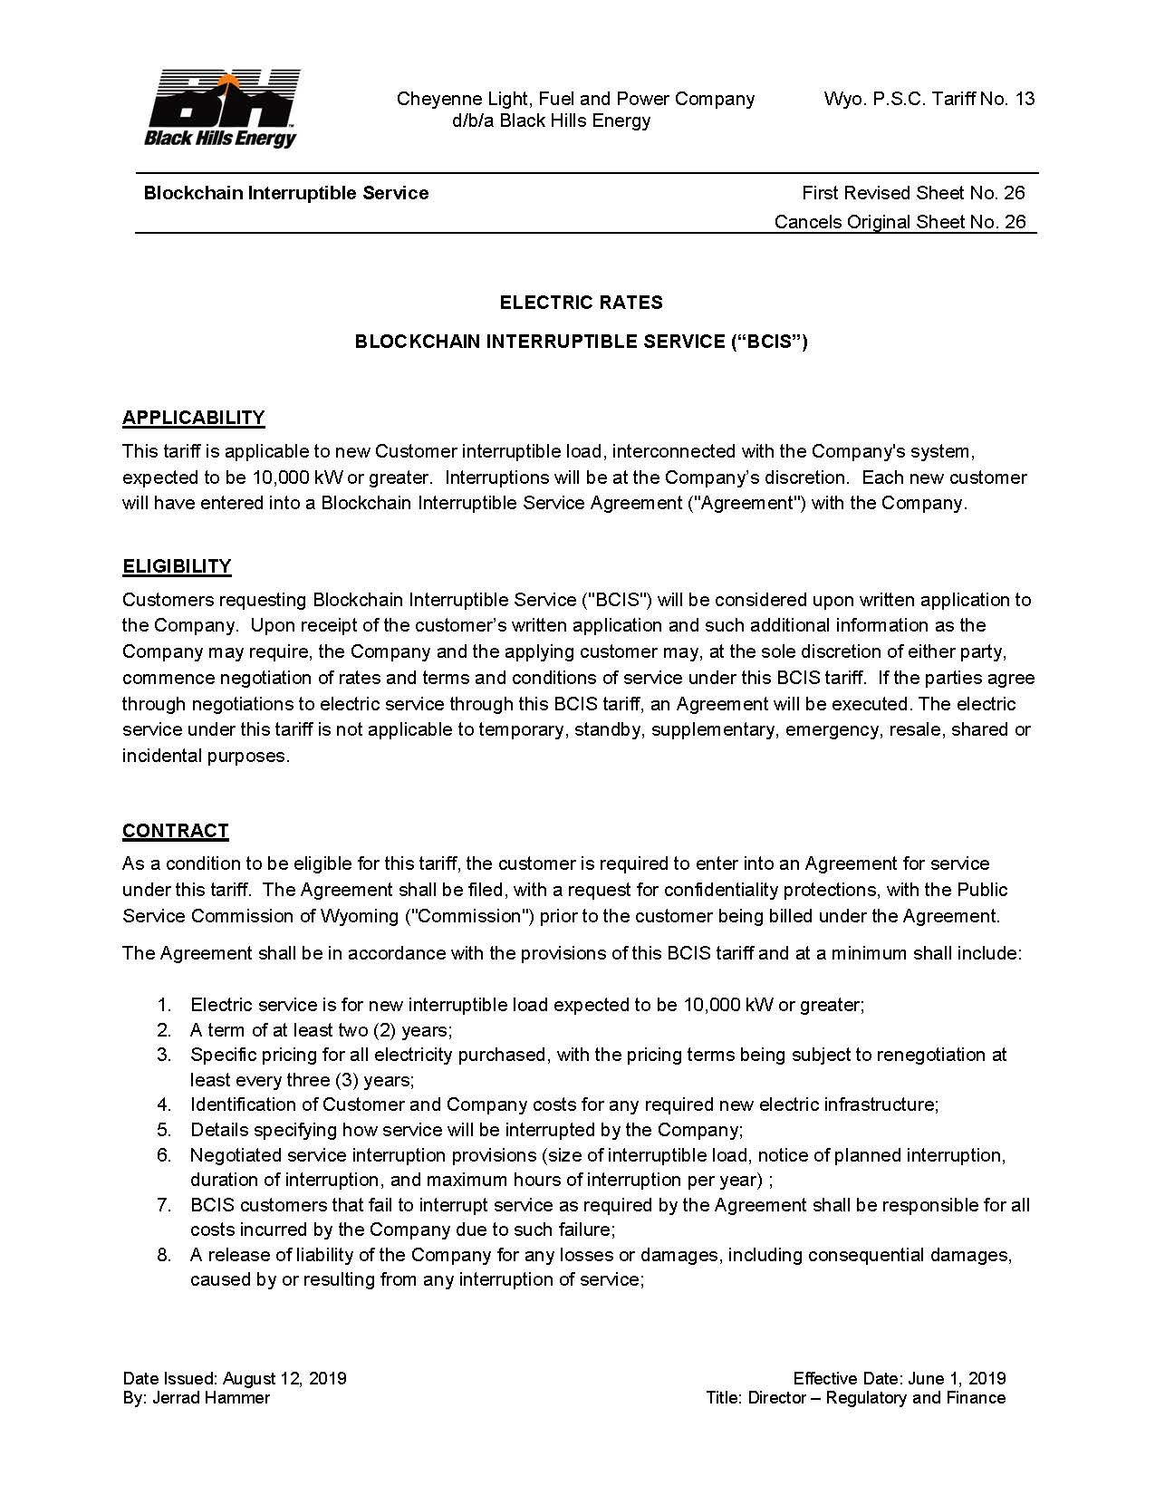
BCIS Tarriff

Appendix - Blockchain Interruptible Service (BCIS) Tariff
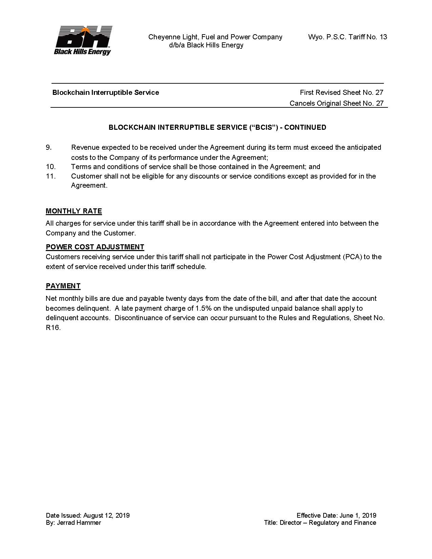
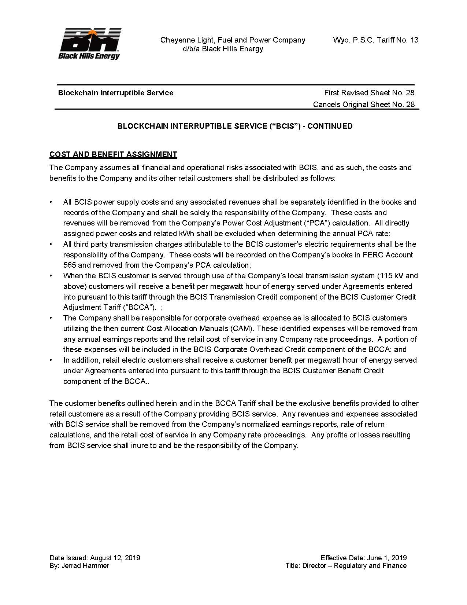
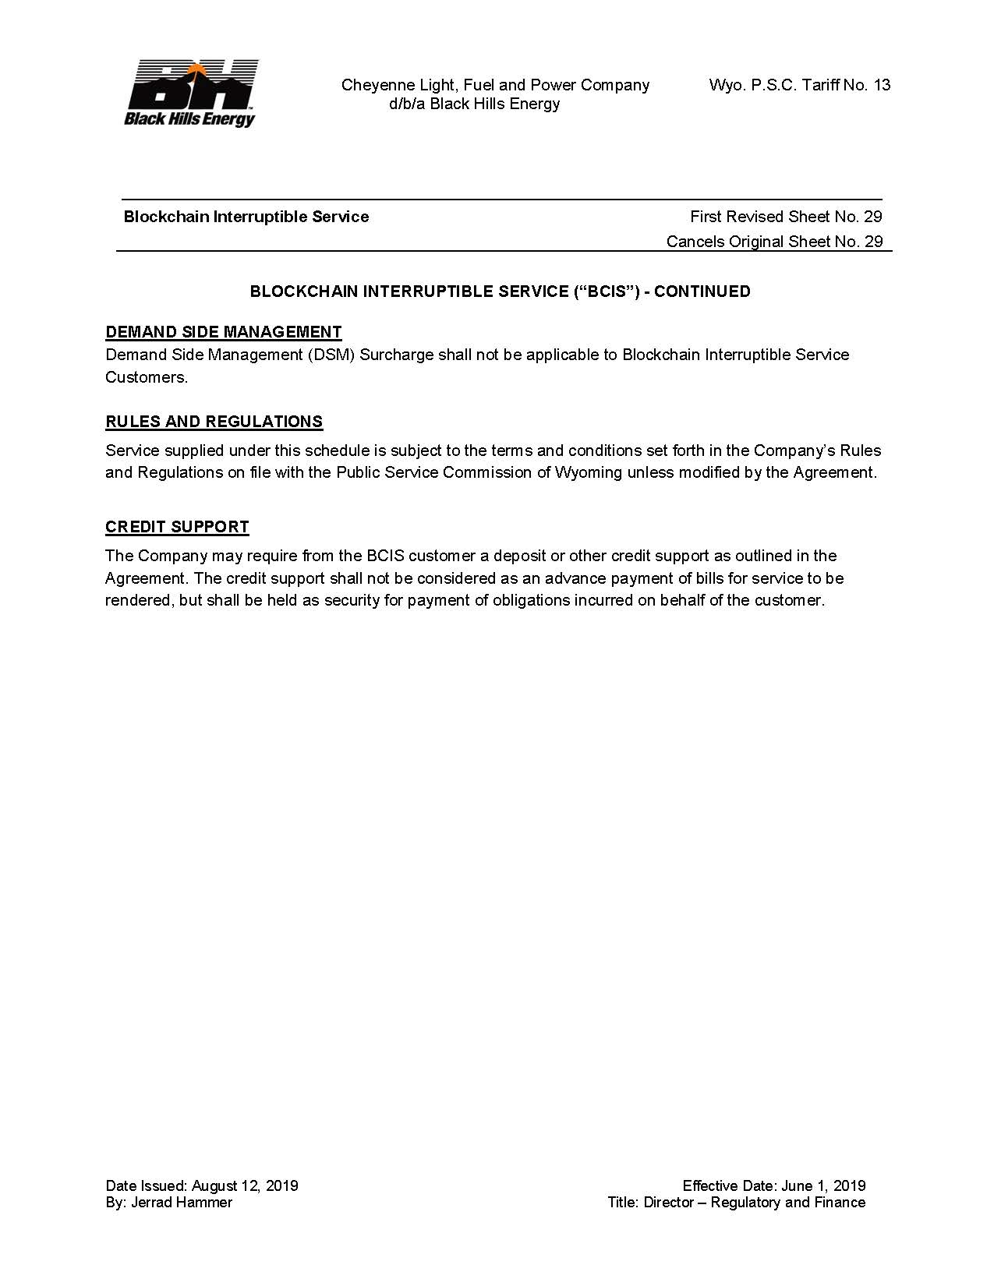

Appendix - Cheyenne Light Substation Availability

Substation | Total Capacity | Reservation for Native Growth | Available BCIS Capacity | Distribution Voltage
Happy Jack | 28 MW | 5 MW | 10 MW | 24.9 kV
North Range* | 100 MW | 83 MW | 0 MW | 24.9 kV
Hilltop | 96 MW | 6 MW | 30 MW | 13.2 kV
Skyline | 96 MW | 9 MW | 35 MW | 13.2 kV
Crow Creek | 96 MW | 8 MW | 15 MW | 13.2 kV
East Business Park | 50 MW | 7 MW | 30 MW | 13.2 kV

*BCIS capacity at North Range could be considered however would require additional analysis.
Note: Capacity listing is the result of arithmetic summation of transformer capacities and does not constitute the results of detailed system analysis. Upgrades such as feeder improvements, service line extensions, multiple metering points, or transmission improvements may be necessary before connecting some or all of this capacity. Prior to connecting any new customer, Black Hills would perform its usual due diligence to identify any system impacts associated with a new customer.

Appendix - Non-Disclosure Agreement

NON-DISCLOSURE AGREEMENT

This Non-Disclosure Agreement (“Agreement”) is effective as of the day of , 2021 (“Effective Date”), by and between [INSERT LEGAL NAME OF ENTITY], a [INSERT ENTITY TYPE], organized under the laws of the state of [INSERT STATE OF ORGANIZATION] having a place of business at (“ ”), and Cheyenne Light, Fuel and Power Company, a company having a place of business at 7001 Mt. Rushmore Rd., Rapid City, SD 57702, and its affiliates and subsidiaries (“Black Hills”). Black Hills and shall collectively be referred to as the “Parties”.

RECITALS

A. The Parties have expressed a desire to engage in discussions regarding a Blockchain Interruptible Service Agreement (the “Transaction”).

B. In order to explore this relationship, it will be necessary for the Parties to disclose certain Confidential Information (as hereinafter defined) to each other.

AGREEMENT

NOW THEREFORE, in consideration of the recitals, the mutual promises and covenants made herein, with the intent to be legally bound hereby, the Parties agree as follows:

1. Confidential Information. As used in this Agreement, the term “Confidential Information” includes all written information, data, correspondence or other tangible materials, and information disclosed orally, electronically or in any other intangible form by one party to the other. Confidential Information shall include all information as described herein, whether or not it is marked Confidential or Proprietary.

Each party shall have the right to determine, in its sole judgment, what information it will provide to the other. Confidential Information shall not include the following:

(a) information which at the time of disclosure by a Party (the “Disclosing Party”) is already public or becomes available to the public through no act or omission of the Party receiving such information (the “Receiving Party”);

(b) information which was in the Receiving Party’s possession prior to receipt from the Disclosing Party;

(c) information which is lawfully received independently from a third party who, to the Receiving Party’s knowledge, is free to disclose such information to the Receiving Party; or

(d) information which is independently developed by or on behalf of Receiving Party without use of any Confidential Information.

Without the other party’s prior written consent, the Parties and their directors, officers, employees, consultants and advisors shall not disclose to any person or entity either the fact that discussions or negotiations are taking place concerning the Transaction between the Parties or any of the terms, conditions or other facts with respect to any such Transaction, including the status thereof.

2. Disclosure and Use of Confidential Information. For a period of three (3) years from the Effective Date of this Agreement, the Parties agree:

(a) to hold in confidence and not to disclose to any third party the Confidential Information, employing the same degree of care to keep such Confidential Information confidential as it employs with respect to its own information of like importance, but in no event less than reasonable care.

(b) not to use the Confidential Information for any purpose other than in connection with the Transaction. The Parties may disclose Confidential Information on a need to know basis to their consultants and advisors and employees who have a need to know such information for purposes of such evaluation, provided that such disclosures are made under confidentiality requirements consistent with those set forth in this Agreement.

(c) With respect to Confidential Information jointly generated by the Parties, each Party shall be deemed to be the Receiving Party for purposes of this Section 2.

3. Required Disclosure. If compelled by a requirement of a government agency, a court, or by law or discovery to disclose any of the Confidential Information, the party ordered to disclose the information shall make reasonable efforts to resist disclosure and shall notify the other party in writing prior to making any disclosure in order to provide the party whose information may be disclosed a reasonable opportunity to either waive any objection to such disclosure or request a remedy from the appropriate authority. The Parties will reasonably cooperate with each other in efforts to obtain such a remedy. If the party whose information may be disclosed waives its objections or is unsuccessful in its request for a remedy or fails to make such a request, the party compelled to disclose information will furnish only that portion of the Confidential Information that is legally required.

4. Return of Documents. The Parties may elect at any time to terminate further access to Confidential Information. The party in possession of Confidential information agrees to return, or destroy if so requested, any and all Confidential Information as well as any other information disclosed upon request, including all originals, copies or any other form of said material, without retaining any copy or duplicate thereof, and shall promptly destroy any and all translations, notes and other written, printed, computer based or readable or other material or information derived from the Confidential Information, without retaining any copy or duplicate thereof. Notwithstanding the foregoing, the party in possession of Confidential Information will not have an obligation to return or destroy Confidential Information stored in electronic backup systems, provided that such systems are not used to access such Confidential Information and the terms of this Agreement will continue to apply to such Confidential Information stored in electronic backup systems.

5. No Further Obligations. Nothing herein shall obligate either party to disclose to or receive from the other party any particular information. Neither of the Parties has an obligation under this Agreement to purchase any service or item from the other party. The Parties shall not be obligated to compensate each other for the use of any information disclosed under this Agreement. acknowledges that Black Hills may explore opportunities similar to the
Transaction with other companies that may be competitors of .

6. Remedies. The Parties acknowledge that remedies at law may be inadequate to protect against any actual or threatened breach of this Agreement, and, without prejudice to any other rights and remedies otherwise available, the Parties agree to the granting of injunctive relief without proof of actual damages. In the event of litigation relating to this Agreement, if a court of competent jurisdiction determines that this Agreement has been breached, then the party at fault will reimburse the other party for its costs and expenses (including, without limitation, attorneys’ fees and expenses) incurred in connection with all such litigation.

7. No Other Rights or License. Disclosure of any information under this Agreement shall not be construed as granting, directly or by implication, any license under any United States or foreign patent, patent application or copyright, or any other intellectual proprietary rights; nor shall this Agreement be construed as creating any agency or partnership relationship between the Parties.

8. LIMITATION OF LIABILITY. NEITHER PARTY NOR ANY OF ITS RESPECTIVE AFFILIATES AND SUBSIDIARIES SHALL BE LIABLE TO THE OTHER OR ANY THIRD PARTY FOR ANY INDIRECT, INCIDENTAL, CONSEQUENTIAL, SPECIAL, PUNITIVE OR EXEMPLARY DAMAGES RELATED TO OR ARISING OUT OF THIS AGREEMENT EVEN IF THE PARTY HAS BEEN ADVISED OF THE POSSIBILITY OF SUCH DAMAGES AND REGARDLESS OF WHAT LEGAL OR EQUITABLE THEORY MAY BE ASSERTED, INCLUDING, WITHOUT LIMITATION, ANY CONTRACT, NEGLIGENCE, BREACH OF WARRANTY OR ANY OTHER LEGAL OR EQUITABLE THEORY.

9. Termination. This Agreement may be terminated by either party upon three days prior written notice to the other party; provided, however, that notwithstanding any termination hereof, the Parties obligations under this Agreement shall remain in full force and effect with respect to Confidential Information disclosed prior to such termination for three (3) years after the effective date of such termination.

10. Non-Solicitation. During the term of the Agreement, and for a period of two (2) years after the active business relationship ends or is terminated for any reason, each party agrees that it will not directly or indirectly, solicit, hire, or retain for employment or contract services, any current employee of the other party or any employee who has been employed by the other party at any time during the term of the Agreement, and who became known to the hiring party in connection with its consideration of the Transaction. Notwithstanding the foregoing, the hiring party shall not be precluded from hiring any such employee who: (a) initiates discussions regarding such employment without any direct or indirect solicitation by the hiring party; (b) is referred to the hiring party by search firms, employment agencies or other similar entities provided that such entities have not been specifically instructed by the hiring party to solicit the employees of the other party or its affiliates or (c) has been terminated by the other party prior to commencement of employment discussions between the hiring party and such employee.

11. Miscellaneous. The Parties represent and warrant that they have the right to disclose the information disclosed under this Agreement for the purpose set forth herein. The Parties shall not disclose any information that is confidential or otherwise restricted by reason of any oral, written or implied agreement or other understanding they have with any third party. This Agreement supersedes all prior agreements, understandings, representations and statements, whether oral or written, between the Parties relating to the subject matter of this Agreement. The terms of this Agreement may not be changed except by subsequent written agreement duly executed by an authorized representative of each of the Parties. This Agreement may not be assigned by either party without the prior written consent of the other party, shall be binding upon the Parties and their successors and permitted assigns, and shall inure to the benefit of and shall be enforceable by the Parties and their successors and permitted assigns. The invalidity in whole or in any part of this Agreement does not affect the validity of the remainder of the Agreement. Notices given under this Agreement shall be in writing and delivered by first class, certified mail to each signatory at the addresses identified herein, unless changed by written notice, with a copy to Black Hills’ General Counsel. This Agreement shall be interpreted in accordance with the laws of the state of Wyoming without regard to its conflicts of laws principles. The venue for any dispute arising hereunder shall be in state or federal courts located within the state of Wyoming. This Agreement may be executed by facsimile and in one or more counterparts, each of which will be deemed to be an original, and all of which when taken together, shall be deemed to constitute one and the same agreement.

The undersigned have caused this Agreement to be duly effective as of the date first set forth above.

Cheyenne Light, Fuel and Power Company

______________________________________ ________________________________
(signature) (signature)

______________________________________ ________________________________
(name printed) (name printed)

______________________________________ ________________________________
(title) (title)

______________________________________ ________________________________
(date) (date)

